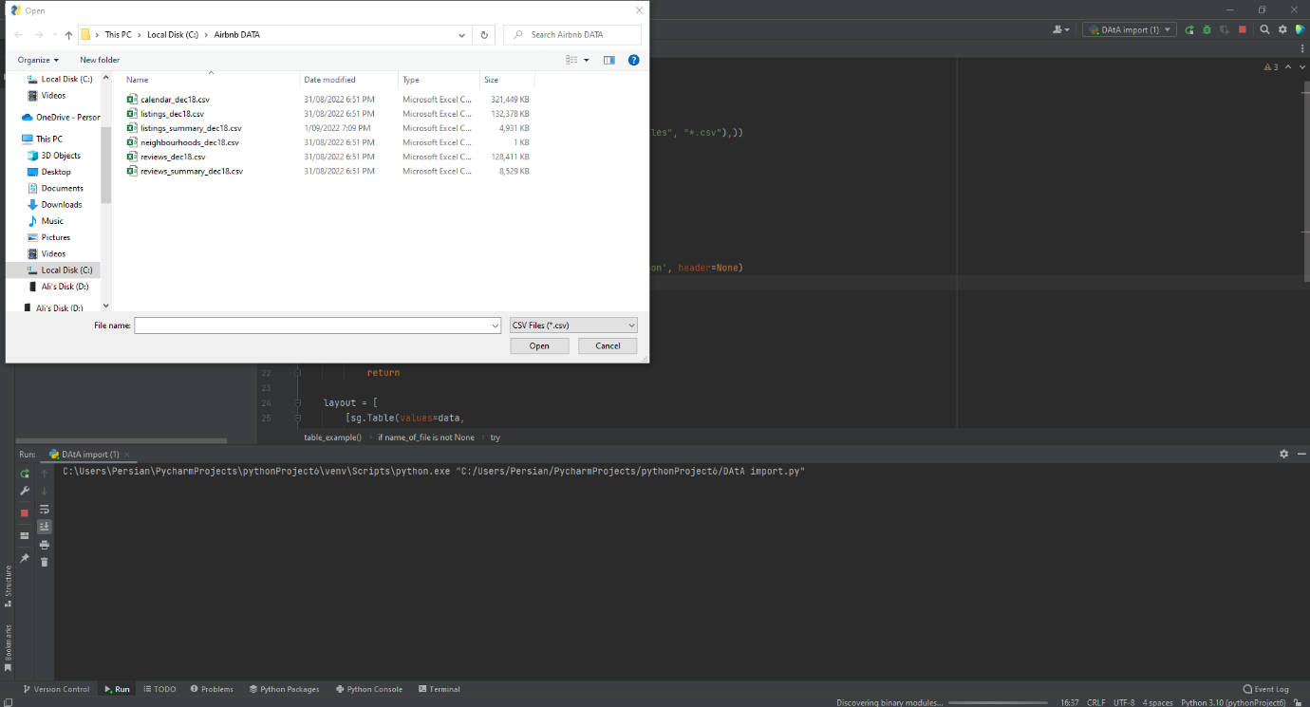Upon testing the info calculator. We discovered that the select file method does not seem like a good idea. This is because not many elderly people or people without any computer experience knowing what to do. Another flaw we discovered is that the file needs to be in an exe format instead of a py format. This is because if someone doesn’t have python installed then they cannot use this app, unless they install python.

